|  |
| --- |
| Waynell_17 Games |
|  |
| Dog running game |
| **[Assignment 1]** |
| Version #1.0 |
| **Waynell Lovell** |



|  |
| --- |
| September 24th 2016 |

**Table of Contents**

**Version History 3**

**Game Over View 4**

**Game Play Mechanics 4**

**Camera 4**

**Controls 4**

**Interface Sketch 4**

**Menu and Screen Design 5**

**Game world 6**

**Levels 6**

**Characters 6**

**Enemies 6**

**Script 6**

**Scoring 6**

**Sound Index 6**

**Design Notes 6**

**Version History**

Github Link: www.github.com/WaynellLovell/COMP305-Assignment01.git

1. **Game Overview**

**Dog runner is a more dodge game. The player’s dog is limited to the screen. The background is an highway. The player must run through traffic dodging cars and drunk drivers and catch tennis balls to gain back lives.**

1. **Game Play Mechanics**

*When player get run over by car they lose lives.*

1. **Camera**

*Camera is in one position.*

1. **Controls**

*Player uses mouse.*

1. **Interface Sketch**

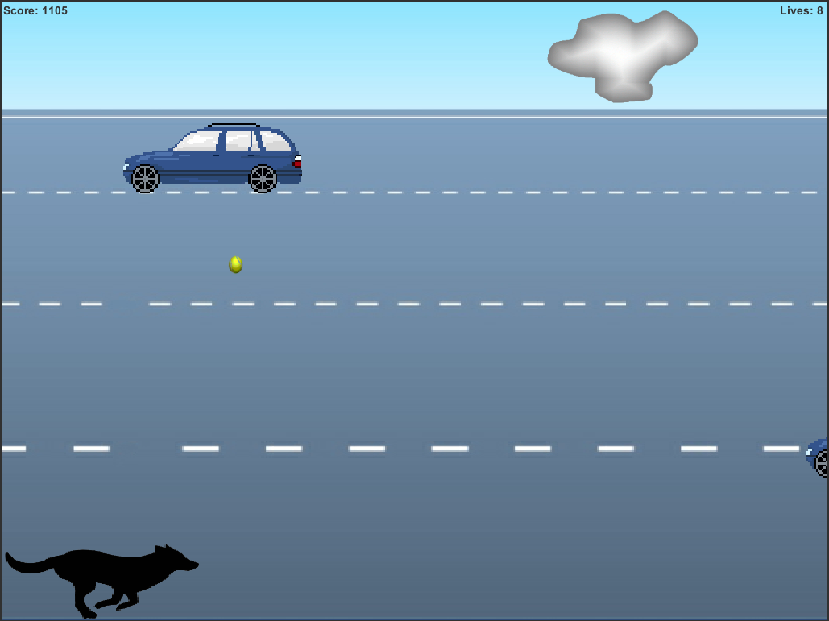

1. **Menu and Screen Descriptions**

Start of Game

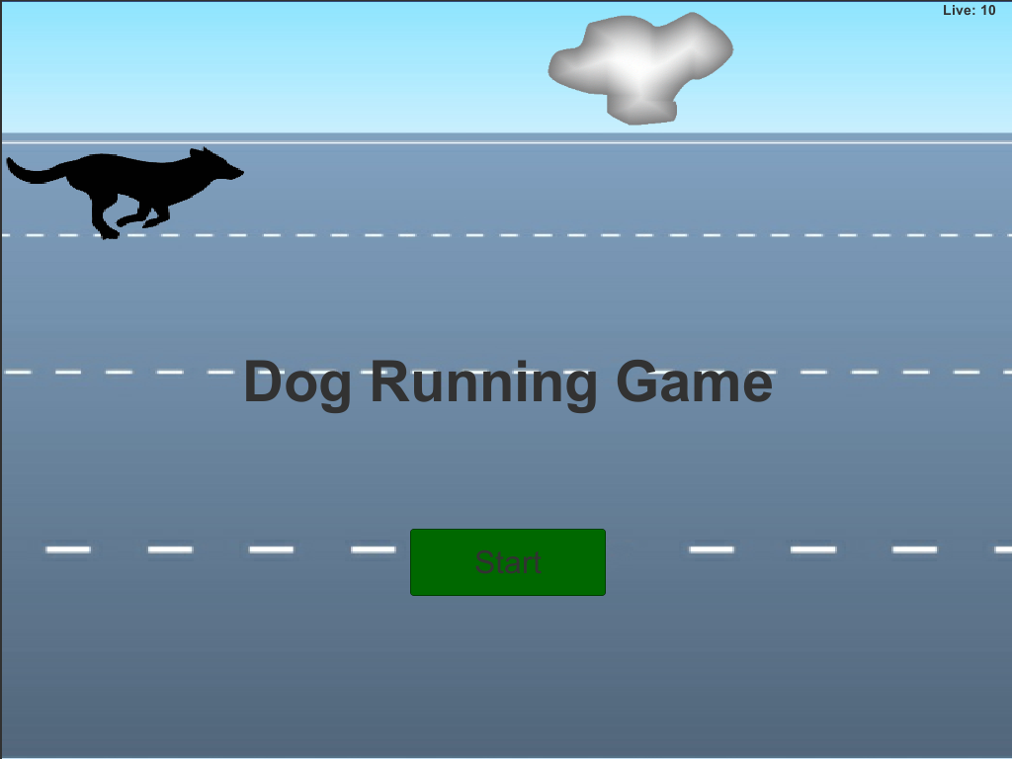

Game Over Screen the player will press R to start over.

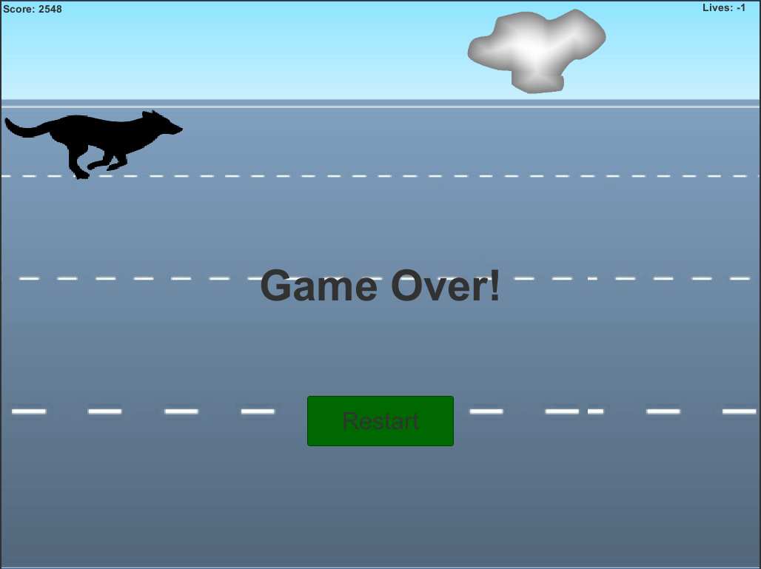

1. **Game World**

*High way that really needs highway patrol.*

1. **Levels**

Higher the score the more cars spawn and aggressive they spawn.

1. **Characters**

*The player’s avatar is a Dog*

1. **Enemies**

*Cars and Drunk Drivers.*

1. **Script**

Background_Controller

Car_Controller

Cloud_Controller

Drunk_Car_Controller

Game_Controller

Player_Controller

Tennis_Controller

Tennis_Ball_Controller

1. **Scoring**

The more the dog is running.

1. **Sound Index**

*Background_sound*

*Car_hit*

*Dog_Bark*

*Dog_Hi*

*GameOver_Sound*

*Life_Up*

1. **Design Notes**

*Most struggling thing was figuring this stuff out.*